Tag Generator User Manual

This program takes as input 3 files:
- WeeklyMenu.csv which is the menu for the week. It must have 8*7 = 56 lines
  - First day of the week is Monday
  - The first 3 lines at the “hot” plates.
  - The first 5 lines may have a side order (salad). This is defined on the 2nd file below.
- WeeklyMenuSide.csv is the side order menu. This file may have 0 to 7 lines. Each line represents as day. You cannot skip a day.
- Orders.csv has the choices of the users. It is created from excel file sent by the client.
You must have all 3 files to run the program. The program will generate up to 3 files per day: Hot, Cold & Side. All 3 files are HTML and you should open them with Chrome. Make sure the file page.css is in the same folder as those files. To print the file use the “print” of Chrome but remove margins first from the options menu.
To run the program:
- Open using notepad the file GenerateTags.exe.config found in the program folder:
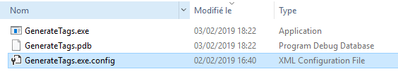
- Open the file and set the path where all your input files will be placed. This will also be the path where the output file will be place. Make sure to have the page.css file copied to that folder as well.
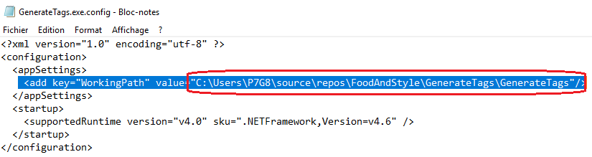
- Open powershell: Click on windows search icon and type “powershell”.
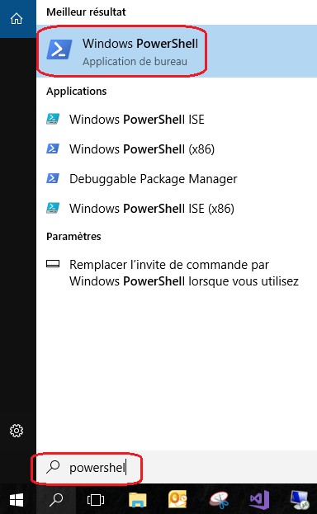
- Go to root drive C: Enter “cd\”
- Got to the folder where you have all the files : “cd c:\<your folder path>“
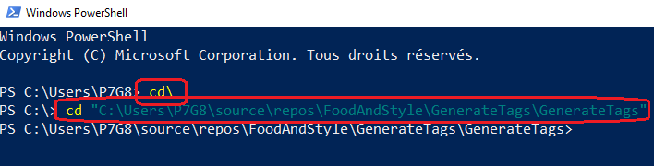
- Enter “.\GenerateTags.exe” to run the program.
In case you already had any html from previous runs they will be overwritten.

